# API COMEXPOSIUM – Exhibitor For Expoplatform

Table des matiÈres

API COMEXPOSIUM – Exhibitor For Expoplatform 1

How to Call API 2

URL to Call 2

SSL certificates 2

Mandatory Parameters 3

Headers Parameters 3

Optional Parameters 4

Query parameters 4

Api returns 9

With a valid subscription key and an Authorized session id 9

Api returns Example 10

For a valid subscription key and an Authorized session id 10

AZURE Developer Portal 11

# AZURE Developer Portal

## How to Access

URL : <https://cxpm-api.developer.azure-api.net/>

1. Sign up to get Access :

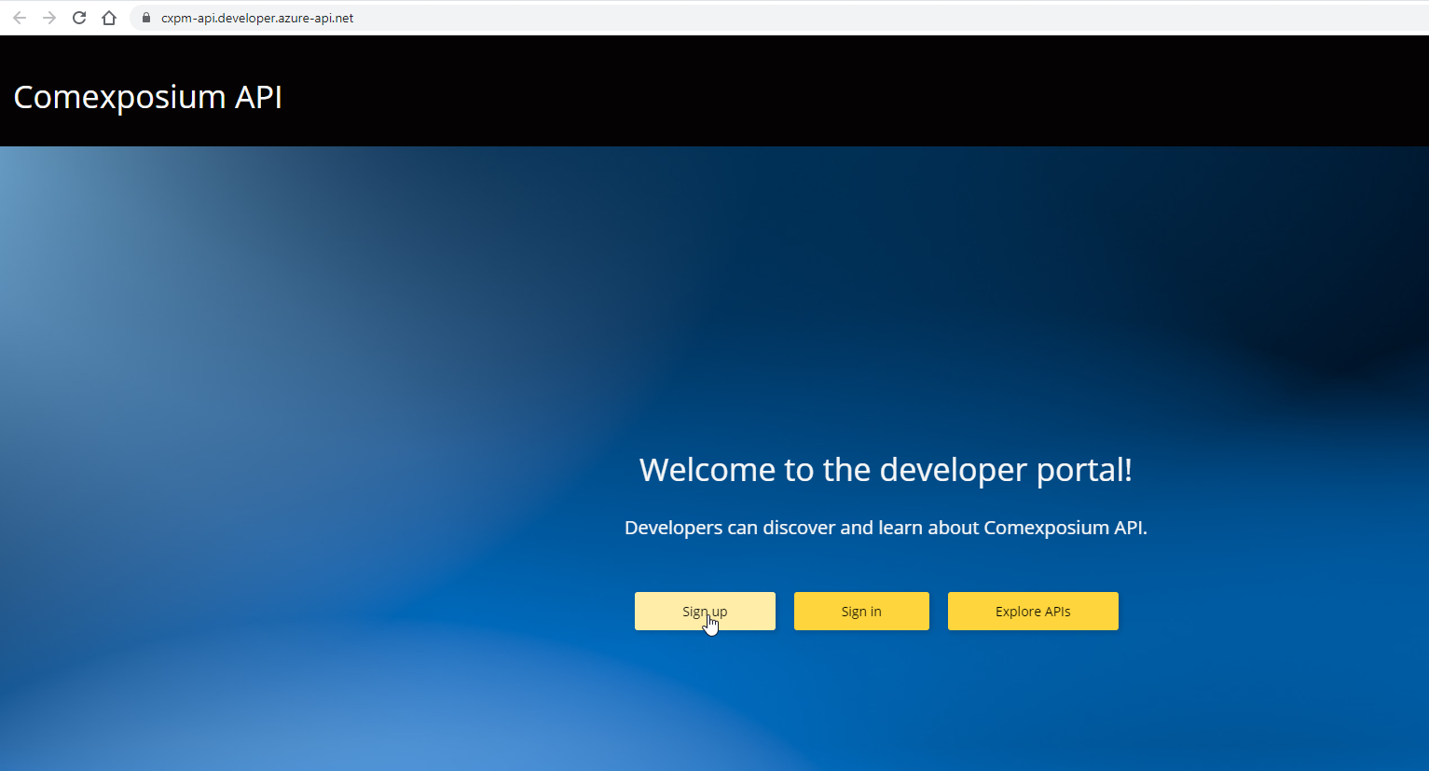

1. Complete the form :

1. Activate your account with the link into the check-in Email :

1. Wait the return of [dsi.teamdata@comexposium](mailto:dsi.teamdata@comexposium) with you Subscribers Key, or ask them by email at [dsi.teamdata@comexposium.com](mailto:dsi.teamdata@comexposium.com).
2. Sign in and Explore Api :

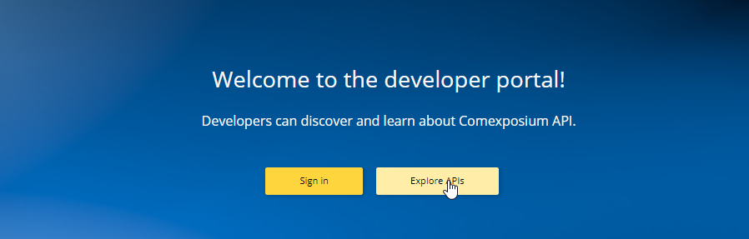

1. Go the the Expoplatform API :

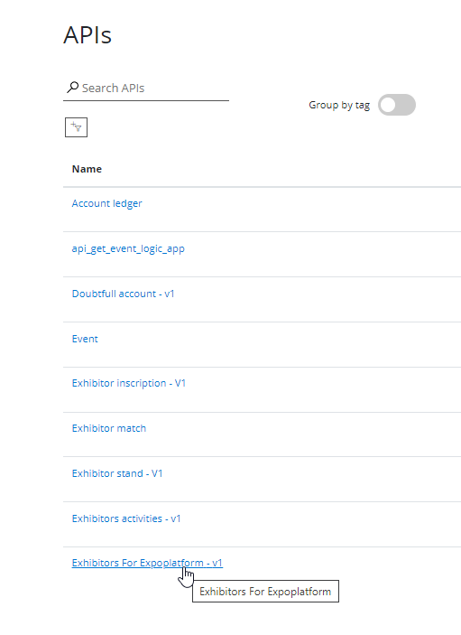

## How to use

The main page contains the API’s description :

The structure of datas :

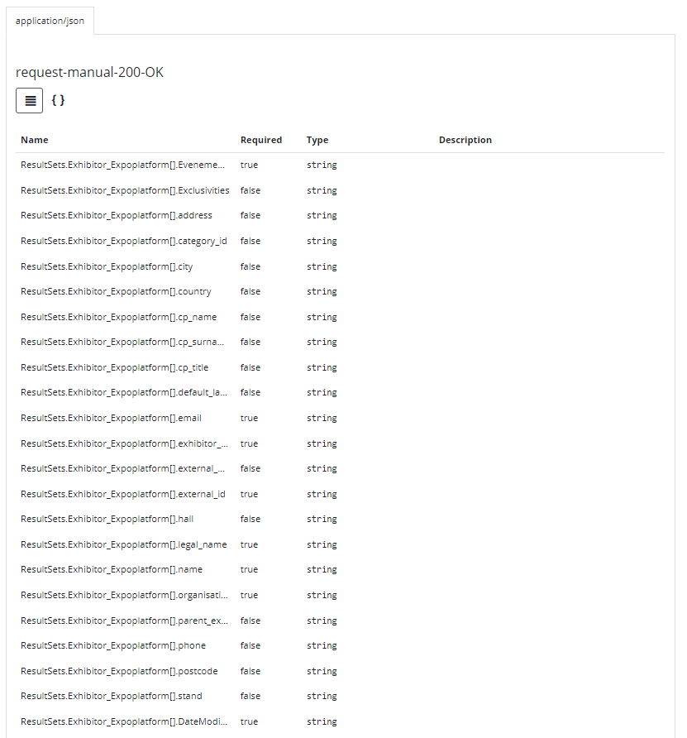

An example of datas :

You can try the api directly by the developer portal :

Enter or not the query parameter :

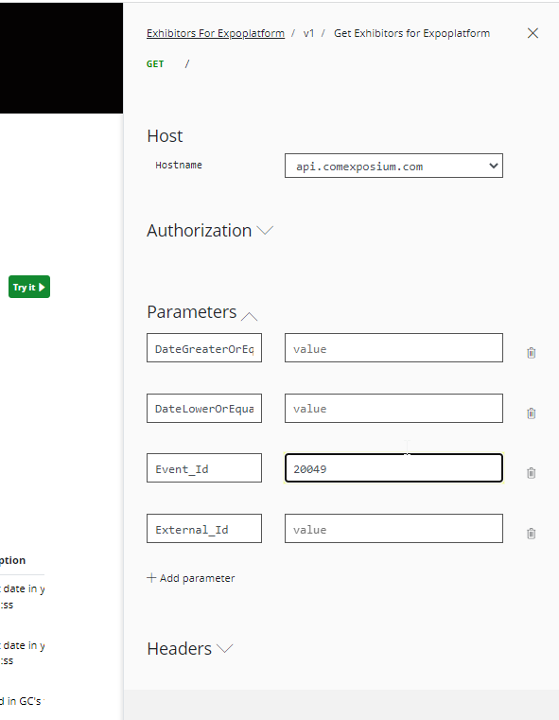

Show the URL to call with parameters :

Send the calling and get the result :

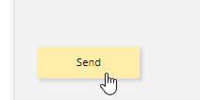

# How to Call API

## URL to Call

<https://api.comexposium.com/Exhibitor/Expoplatform/V1/>

You must use « GET » Method to call this api.

## SSL certificates

To secure the communication, you must set up our SSL certificate at your end and allowed the SSL communication.

The SSL certificate could be asked at [dsi.teamdata@comexposium.com](mailto:dsi.teamdata@comexposium.com)

To import it on PostMan :

* Go on application settings : Une image contenant texte

  Description générée automatiquement Une image contenant texte

  Description générée automatiquement
* On General, verify the SSL certificate verification : Une image contenant texte

  Description générée automatiquement
* On Certificates, import the PEM file, and enable CA Certificates : Une image contenant texte

  Description générée automatiquement
* Ensure to activate SSL certification on api call :
* 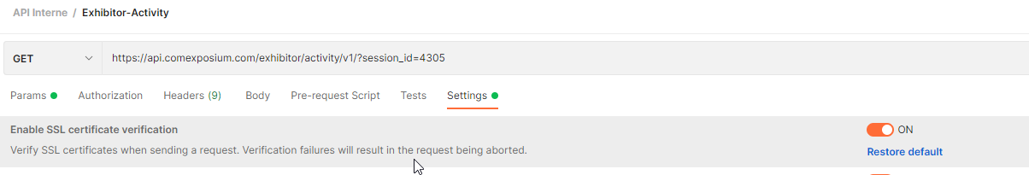

## Mandatory Parameters

### Headers Parameters

Ocp-Apim-Subscription-Key= « String »

All apis are secured by an azure subscription. It’s mandatory to set this header parameter « Ocp-Apim-Subscription-Key » to pass api call’s security.

The subscription key could be asked at [dsi.teamdata@comexposium.com](mailto:dsi.teamdata@comexposium.com)

If the Ocp-Apim-Subscription-Key is not defined, you will get this return :



## Optional Parameters

### Query parameters

#### Event_id= « Integer »

It’s Comexposium's internal ID of the Event. It corresponds to the ID of the Event in Comexposium's system.

For example, the Event_id 20049 is for Wine Paris 2023, wich is the Id 217 in Expoplatform.

In case you do not know this ID, you can retrieve a full dataset including all the available session in the field « Evenement_IdGC ».

#### External_ID = « STRING »

It’s Expoplatform's external_id. It corresponds to the concatenation of string « VX- » with the Account’s id in Comexposium's system.

For example, external_id « VX-470878 » corresponds to Comexposium’s account « 470878 » with the legal name « CLOS DES NINES ».

It can be used to get data for one external_Id. For example in API Call :

#### DateGreaterorequalsthan = « DATE/DATETIME »

The datas for Expoplatform are stored by date of modification.

The query parameter DateGreaterOrEqualsThan can be used to get update’s data since last update corresponding to this value.

The field « LastUpdate » return this information.

For example, DateGreaterOrEqualsThan=2023-01-15 return all datas updated since the 2023-01-15 00:00:00.

DateGreaterOrEqualsThan=2023-01-17 09:15:00 return all datas updated since the 2023-01-17 09:15:00.

#### Datelowerorequalsthan = « DATE/DATETIME »

The datas for Expoplatform are stored by date of modification.

The query parameter DateLowerOrEqualsThan can be used to get data updated before this date value.

The field « LastUpdate » return this information.

For example, DateLowerOrEqualsThan=2023-01-19 return all datas updated before the 2023-01-19 00:00:00.

DateLowerOrEqualsThan=2023-01-17 09:15:00 return all datas updated before the 2023-01-17 09:15:00.

#### Combination of Each parameter

Each parameter can be combined with the others.

You can pass « Event_Id » with « DateGreaterOrEqualsThan » and « DateLowerOrEqualsThan » to get all datas for one Event_id between two dates.

For example, if you want to get data modified between the 2022-12-30 and the 2023-01-01 03pm for the Event_id 20049 :

# Api returns

### With a valid subscription key and an Authorized session id

API Return Response-200 for 200 OK

Content type – applicatio/json  :

|  |
| --- |
| {  "properties": {  "OutputParameters": {  "properties": {},  "type": "object"  },  "ResultSets": {  "properties": {  "Exhibitor_Expoplatform": {  "items": {  "properties": {  "Evenement_IdGC": {  "type": "string"  },  "Exclusivities": {  "type": "string"  },  "address": {  "type": "string"  },  "category_id": {  "type": "string"  },  "city": {  "type": "string"  },  "country": {  "type": "string"  },  "cp_name": {  "type": "string"  },  "cp_surname": {  "type": "string"  },  "cp_title": {  "type": "string"  },  "default_lang": {  "type": "string"  },  "email": {  "type": "string"  },  "exhibitor_category": {  "type": "string"  },  "external_exhibitor_id": {  "type": "string"  },  "external_id": {  "type": "string"  },  "hall": {  "type": "string"  },  "legal_name": {  "type": "string"  },  "name": {  "type": "string"  },  "organisation_name": {  "type": "string"  },  "parent_exhibitor_id": {  "type": "string"  },  "phone": {  "type": "string"  },  "postcode": {  "type": "string"  },  "stand": {  "type": "string"  },  "DateModification": {  "type": "string"  }  },  "required": [  "Evenement_IdGC",  "external_id",  "name",  "legal_name",  "organisation_name",  "email",  "exhibitor_category",  "DateModification"  ],  "type": "object"  },  "type": "array"  }  },  "type": "object"  }  },  "type": "object"  } |

# Api returns Example

### With a valid subscription key

For the session Wine Paris 2023 (Event_Id : 20049) with the external_Id VX-2027925.

|  |
| --- |
| {      "ResultSets": {          "Exhibitor_Expoplatform": [              {                  "Evenement_IdGC": "20049",                  "external_id": "VX-2027925",                  "external_exhibitor_id": "VX-3101339",                  "parent_exhibitor_id": "VX-2019214",                  "name": "EARL DANIEL REVERDY ET FILS",                  "legal_name": "EARL DANIEL REVERDY ET FILS",                  "organisation_name": "EARL DANIEL REVERDY ET FILS",                  "email": "daniel-et-fils.reverdy@wanadoo.fr",                  "category_id": "option-1",                  "Exclusivities": **null**,                  "exhibitor_category": "Exhibitor",                  "hall": "H3",                  "stand": "B 216",                  "cp_title": "Mr",                  "cp_name": "Cyrille",                  "cp_surname": "REVERDY",                  "default_lang": "FR",                  "phone": "0685040035",                  "address": "Chaudenay",                  "city": "VERDIGNY",                  "country": "FRANCE",                  "postcode": "18300",                  "LastUpdate": "2022-12-30T07:10:11.588"              }          ]      },      "OutputParameters": {}  } |

### If they is no data to return

The result is empty :

